Instructions on completing Excel Time sheet
On the top of the page you are require to enter in your Last and First name, Employee ID, Org/Dept and select the Pay period start date from the drop down list. Once you select the pay period begin date, the pay period end date will default in. Only enter in the Grant # and Grant title if your wages are to be charged to a particular grant. Below is an example of what the page might look like.
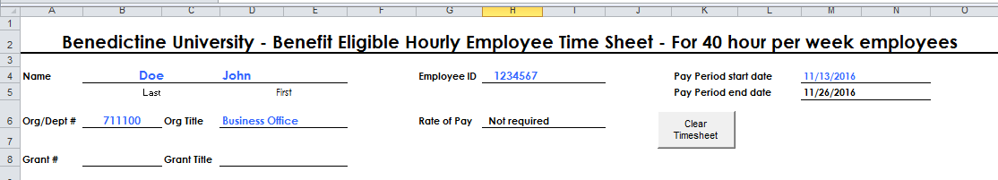
In order to ensure accurate and prompt processing of your payroll check, it is essential that hourly paid employees record an accurate and complete statement of your time on your timesheet. You must specifically record arrival time, time in and out for lunch, and departure time on a daily basis.
The punch in and out times need to be entered in using a particular format, you can enter punches in military hour format, for example 8:00 for 8am or 17:00 for 5pm. Another option is to enter in the actual time, for example 8:30 AM, but you must include a space between the time and the AM of PM. Please round to the nearest 15 minute increment when entering punches, often referred to as the 7 minute rule. An example of the 7 minute rule would be, if you arrive to work 8:07, you would round down so you would punch in at 8am, but if you arrived at 8:08 you would round up and punch in at 8:15am.
Example 1 – Regular 40 hour week with no PSV time taken -- This is what a time sheet might look if no personal, sick, vacation or holidays were taken. You’ll notice that the total actual hours worked for the week totaled 37.75 hours. Full-time benefit eligible hourly employees will be compensated for 40 hours per week, but are required to work a minimum of 37.5 hour per week. In the example below the employee actually worked only 37.75 hours, the payroll department would compensate them for 40 regular hours of pay.
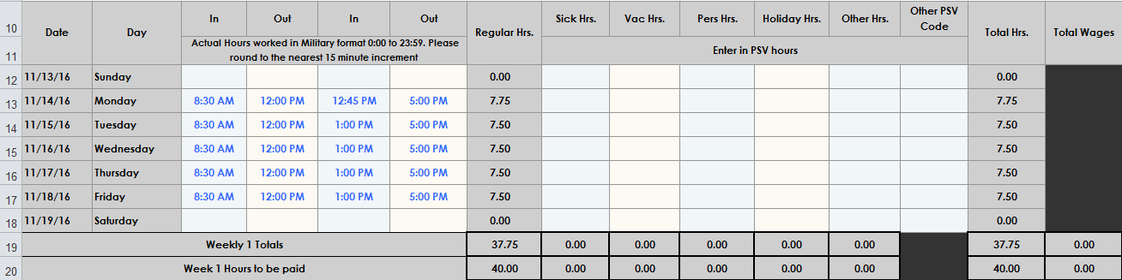Example 2 – Entering personal, sick or vacation time -- Hourly employees must record personal, sick and vacation time taken on their bi-weekly time sheet. The number of hours that you record on your time sheet should be based on the number of hours the employee would normally have been scheduled to work that day. In the example below the employee would be paid for 24 regular hours, 8 hours of sick pay, and 8 hours of vacation pay.
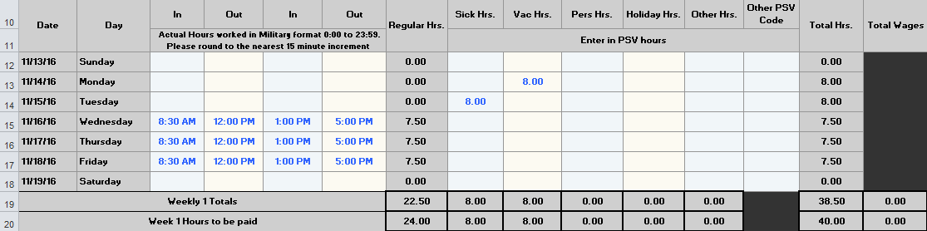
Example 3 – Entering holiday pay -- For hourly employees working 2080 hours in a fiscal year, a paid holiday will be considered to be an 8-hour day, regardless of the weekly work schedule. For part-time benefits eligible hourly employees, holiday pay is equal to the average daily hours in a five-day workweek. In the example below the employee would be compensated for 40 hours of holiday pay.
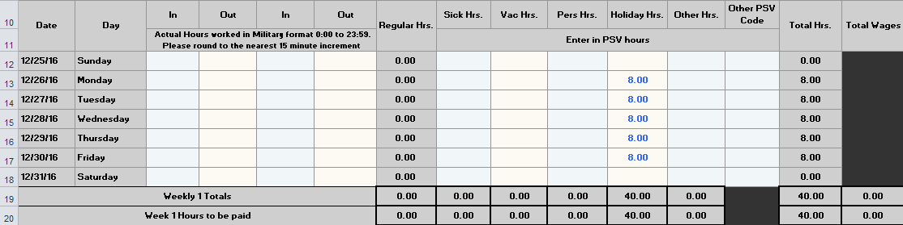
Example 4 – Working on a Holiday - In the example below the employee worked 4 hours during the Christmas break. They would punch in and out for their time worked and they would also list their holiday hours. In the example below the employee worked 4 hour during the holiday, theywould be paid for 40 hours of holiday pay and 4 hours of regular pay.
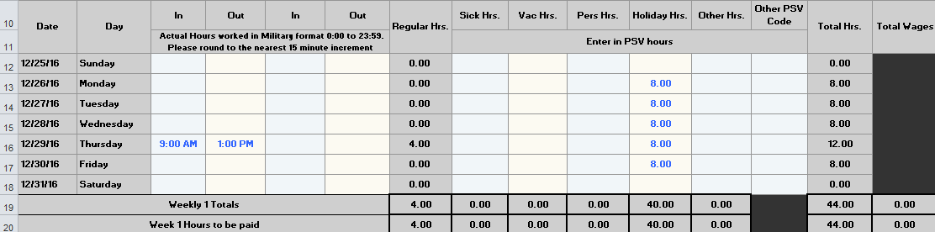

Example 5 - Taking less than a full day of PSV time – If you take a partial day of PSV time, the number of hours that you enter in as PSV time should be the number of hours that would allow you to report the full amount of time you were scheduled that day. In the example below the employee is on a typical 40 hour per week 8 hours per day. They leave early due to illness on Monday and recorded actual work time of 4.5 hours that day, to get to the full 8 hour day, they would enter 3.5 hours of sick time. The employee also worked 4 hours on Friday and took the afternoon off as vacation. To get to the full 8 hour day, they would enter 4 hours of vacation time on Friday. In the example below the employee would be paid for 32.5 regular hours, 3.5 hours of sick and 4 hours of vacation for a total of 40 hours.
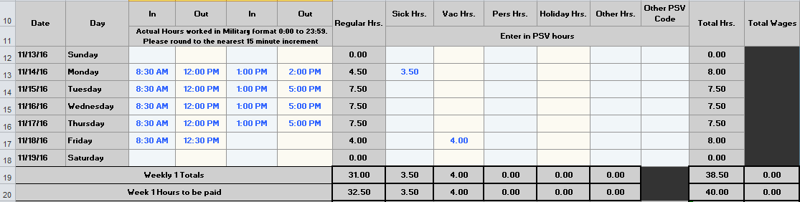
Example 6 - Recording time off for Official Close – If early dismissal occurs, benefit eligible employees present will be paid for their regular work schedule. If an employee has planned Vacation or Personal time or calls in sick on a day which is then officially closed (through authority of the President), due to Severe Weather, then that employee will be paid as an official closure day and no personal, sick or vacation time will be deducted from the employee. Employees who choose or are required to work on a day that is officially closed due to severe weather will not receive an alternate day to use at a later time. In the example below the employee was scheduled to work 8 hours each day, the university closed at noon on 11/15/16 due to severe weather and remained closed on 11/16/16. The employee worked 3.5 hours on 11/15, so they would mark on their time sheet 5.5 other hours and select from the drop down list a PSV code of “O – Official Close” on 11/15, and 8 other hours with a PSV code of “O – Official Close” on 11/16. 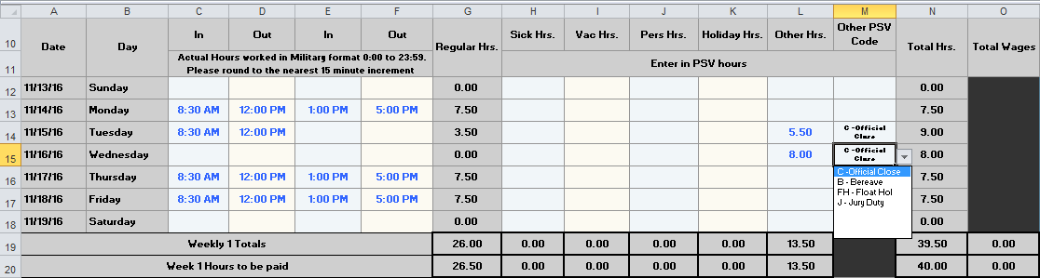Example 7 - Recording time off for Bereavement leave, Floating Holiday, and Jury Duty -- The number of hours that you record on your time sheet for bereavement leave, floating holidays, and jury duty should be based on the number of hours the employee would normally have been scheduled to work that day. In the example below the employee took 8 hours of bereavement leave, floating holiday, and jury duty in the same week.
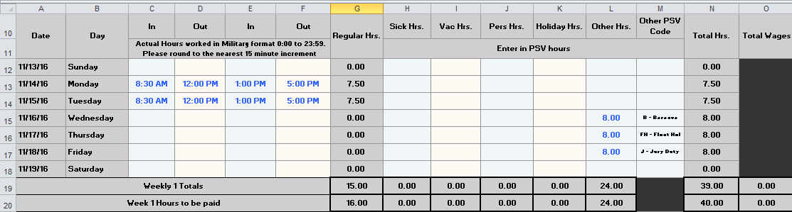
Example 8 &9 – Recording overtime – Hourly paid employees will be paid overtime for hours actually worked in excess of 40 hours per week. For purposes of calculating overtime, lunch periods of 30 minutes or more, holidays, vacation days, personal days and sick leave are not considered as hours worked when computing overtime hours and pay. Hourly paid employees are not eligible for “comp” time because they must be paid for hours worked, as required by the Fair Labor Standards Act (FLSA). The employee does not need to enter in their overtime hours, the overtime hours will be automatically calculated when your punch in and out times for the week are entered in the Excel time sheet.
In the example below the employee actually worked 50 hours in the week so they would be paid for 40 regular hours and 10 hours of overtime. 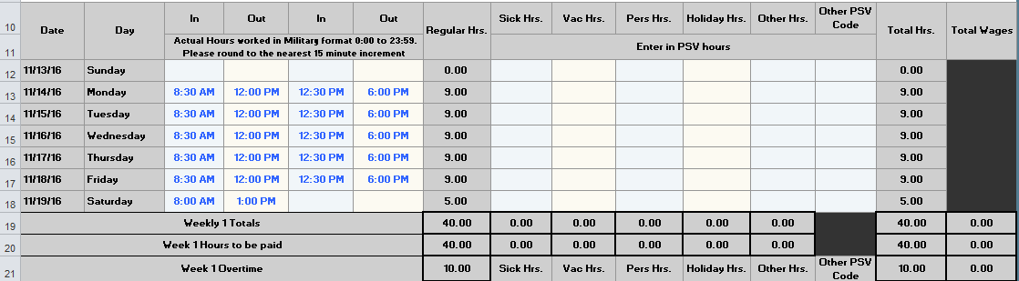
In the next example, the employee called in sick one day so their actual hours worked was 41 hours. They would be paid for 40 regular hours, 8 hours of sick time and 1 hour of overtime. 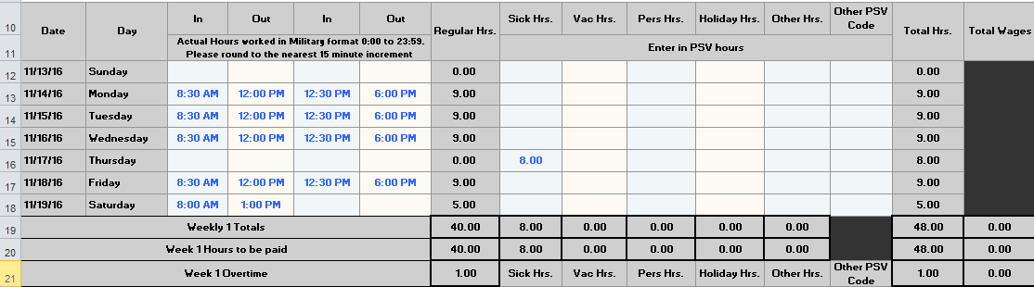
Clearing timesheet punches – If you wish to clear your punch in and out times after each week, you can click the “Clear Timesheet” macro button and it will clear all your punch in and out times as well as any PSV hour that you entered in for both weeks. If you work the same schedule each pay period, it may be easier to modify your punches from the previous week instead of clearing them out each period. 